**Exemplar: The Gift of Elders**

**nehiwayak (Plains Cree) Artifact**



https://www.glenbow.org/media/cree_full_lp_package.pdf

**English:** Collar or cape (necklace)

nêhiyawêwin: [tapiskakan](http://www.creedictionary.com/search/index.php?q=tapiskakan&scope=1&cwr=19726) ᑕᐱᐢᑲᑲᐣ

**Additional Artifacts from other Cultures**

In partners, listen to and practice and then write the names of additional artifacts from other cultures:

[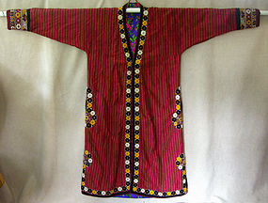](http://www.trocadero.com/ethnic/items/1029349/en1.html)

http://www.trocadero.com

**English**: traditional Robe

**Additional Language:** **روب**

**Name and Origin of Additional Language**: Urdu, Pakistan

**(Out of 7 Marks)**

**Template**

**The Gift of _______________**

**nehiwayak (Plains Cree) Artifact**

**English:**

**nêhiyawêwin:**

**Additional Artifacts from other Cultures**

In partners, listen to and practice and then write the names of additional artifacts from other cultures:

**English**:

**Additional Language:**

**Name and Origin of Additional Language**: