**The Medicine Wheel, by Jan Beaver**

The medicine wheel is the circle of life. All of creation ______ represented on the medicine wheel. The medicine wheel also includes all nations on Earth and that all things in life and in the universe are in a circle. The life cycle ______ circular from birth to childhood to youth to adulthood to old age and finally to death and rebirth. These teachings ______ divided into the four directions.

**East**

In the east, the colour ______ yellow. The yellow nation ______ in the East. It is the dawn time of day. East represents birth. It _____ the season of spring and the time of new life. The Eagle ______ in the East and flies closest to Great Mystery or Creator, Kitchie Manitou. The Eagle gives messages between people and Creator. In the east, we learn about kindness, open mindedness, joy, truthfulness, hope, guidance and leadership.

**South**

In the South the colour _______ red. The red nation is in the south and the middle part of the day. It is the season of summer and the time of youth. The animal of the south ______ the deer to teach us about being generous because deer gives us meat to eat and skins for our clothing, drums and shoes. Deer also teaches us to be loyal, honest and respectful. The sacred medicine ______ cedar, burned to protect your body from disease.

**West**

The colour of the west _______ black. It is fall and the time when you are an adult. The black nation is in the west. In the west is a doorway through which all people must go when they leave the Earth for the Spirit World. The buffalo guards this doorway. For some native peoples further south, the bear _______ in this direction. The buffalo is sacred to the native people because of everything buffalo has given us to help us to survive.

**North**

The colour of the north ________ white. It is the night time and the winter of the year. It is the time of your life when you ________ an elder. The white nation is in the north. The sacred medicine of the north _________ the sweetgrass. It was the first plant to grow on Mother Earth. The bear teaches us about fasting because the bear goes to sleep in the winter and doesn't eat for a long time until the spring. The lessons learnt in the north are about strength, truth and wisdom As an elder, you _________ respected and taken care of. Everyone must take very good care of their elders and listen to their advice.

**Out of 16 Marks**

**Once you have filled in the blanks above, re-read and then, label the Medicine Wheel directions and what each direction signifies**

**Spiritual**

**East**

**Label the Cree Medicine Wheel**

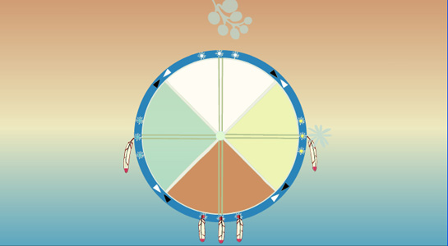

**Do you have similar or different spiritual beliefs and celebrations?**

**Compare and contrast differing beliefs and celebrations using the graphic organizer below. Then, write a few rough copies (using informal and formal English) and a final copy using formal English. Make sure your partner checks for formal English and makes notes of any informal English that needs to be changed for the final copy. You must write two paragraphs of 6 to 8 sentences each that compare and contrast your spirituality and Aboriginal spirituality. If you are First Nation’s Inuit or Metis and share the worldviews discussed, choose a partner in our class from a different spiritual background and work with them to compare and contrast (See Rubric in Appendix for Assessment).**

**The Gift of Life: Describing my Artifact**

Informal to formal Differences

Work together to make jot notes on the side of your work and your partner’s work to highlight informal to formal writing from your rough to good copies.

Title: _____________________

____________________________

Title: __________________

____________________________________

**Once you have completed all rough copies (at least 3) and a good copy of your compare and contrast paragraphs, fill out this exit slip to describe your learning.**

**Out of 16 Possible Marks Total**

**Exit Slip**

How did your writing change from your rough (informal) copy to your final copy? Did you notice any writing feature changes after you finished? If so, what features changed?

Were you able to help guide your writing partner to use formal writing and change their writing style?

What subject-verb-agreement changes did you make?

Did you change any possessive nouns from your informal to formal copies?

What are some of your new learnings about your own culture and Aboriginal culture?

What do you think you need more help with? Are there language or cultural ideas you do not understand?